CUSTOMER-CENTRIC: HOLISTIC APPROACH

PROFIT SECURITY

EXECUTIVE SUMMARY

Background

The bank’s customer cycle is a critical process that encompasses all aspects of customer interaction, from acquisition to retention. It is important to understand this cycle to identify opportunities to improve customer retention and profitability.

The EXIM Bank’s customer cycle scrutinized from the perspectives of profit security and churn prediction. Profit security is concerned with securing the bank's earning by identifying and mitigating risks associated with customer criteria, while churn prediction is the process of identifying customers who are at risk of leaving the bank and taking their business elsewhere.

The importance of profit security is essential for banks to maintain their profitability and financial stability, while churn prediction can help banks identify and retain valuable customers, which can lead to increased revenue and profitability. Ultimately, the bank can identify several strategies optimising asset allocation and that it can use to improve profit security and reduce churn.

Contents as per below:

Security
- Security of Trade and Non-Trade
- Security Portfolio
- Security Criteria Prediction

Financing Asset Quality
- Overall Financing Asset
- Impaired Ratio
- Impaired Behaviour
- Accounts Migration
- Cycle Diagram
- Customer Churn Prediction

Problem statement
The bank is facing increasing competition from both traditional and fintech rivals. As a result, it is more important than ever for it to focus on customer retention and profitability. However, many banks struggle to allocate their asset correctly, to predict which customers are at risk of churning and to develop strategies to prevent it. This can lead to significant losses in revenue and profits.
A machine learning model is necessary to accurately predict which customers are at risk of churning and recommend interventions to prevent it. This model will be trained on a variety of data, including customer demographics, history, and facility. By predicting churn and intervening early, banks can reduce churn rates, increase profits, and improve customer retention.

Security of Trade and Non-Trade
EXIM Bank's primary line of business is to provide credit facilities to finance and support exports and imports of goods, services, and overseas projects with emphasis on non-traditional markets as well as the provision of export credit insurance services, export financing insurance, overseas investments insurance and guarantee facilities.
Throughout the year, both trade and non-trade customers, as well as its financing asset's client base and cumulative profit payment are slowly decreasing while accrued profit slowly increases. Figures below shows the number of accounts, gross financing asset, cumulative accrued profit, cumulative profit payment and profit security ratio by trade and non-trade facility from year 2020 until 2023:
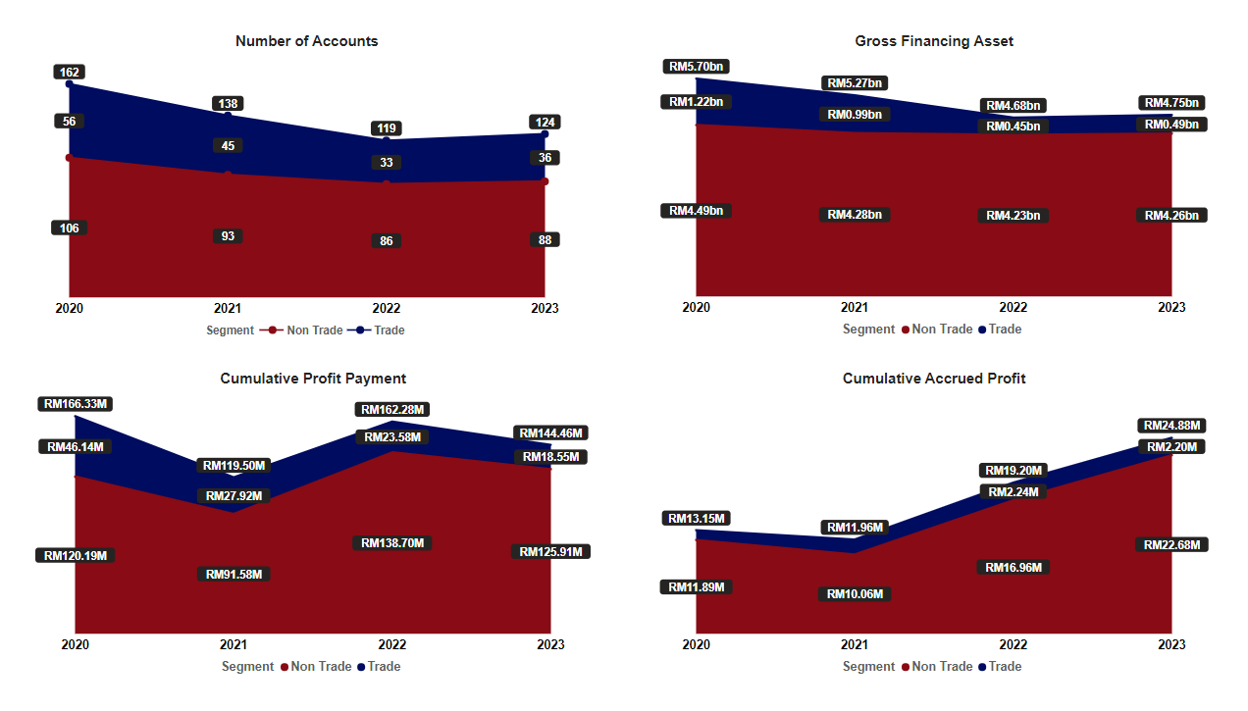
Figure 3.0
Figure above shows, the majority for number of accounts, gross financing asset, cumulative profit payment and cumulative accrued profit consist of non-trade compared to trade. Both trade and non-trade slowly decreases from year 2020 until year 2023 except for cumulative accrued profit that increases from year 2020 until year 2023.
Though most profit is from non-trade amounted between RM91M – RM140M while trade is between RM19M – RM47M, but in Figure 3.1 the profit security ratio will show Trade is more profitable whereby higher ratio means the profit is more secure and less asset is needed to earn profits or higher profit can be gain for trade if the cost for trade and non-trade is the same.

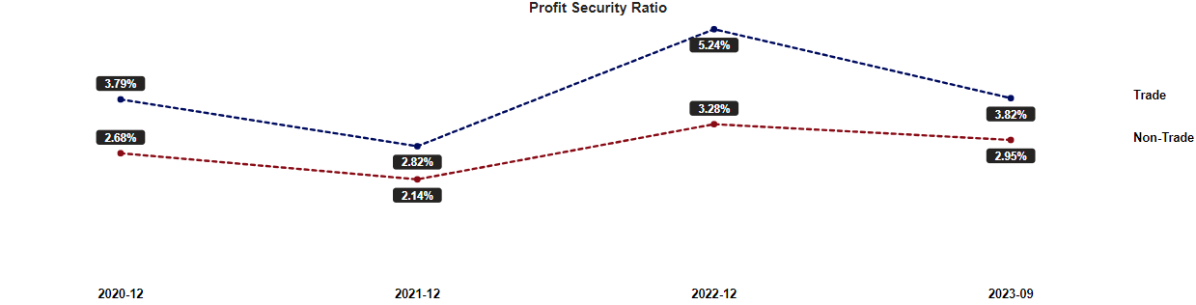
Figure 3.1
Although trade facility has an overall small portion for number of accounts, gross financing asset, cumulative profit payment and cumulative accrued profit. But the trade profit security ratio shows significantly higher that non-trade facility meaning a better security for the bank to generate profit and confident trade is key to the bank ‘s long-term growth strategy. Therefore, believing that our focus quality is paying off, trade financing will continue to grow in importance over time.
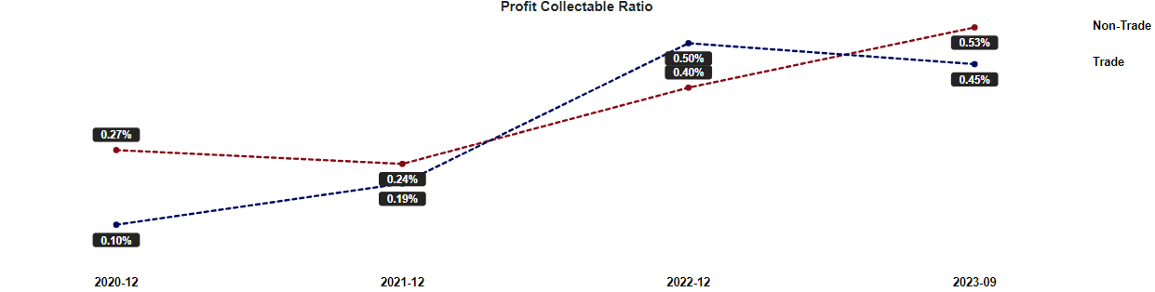
Figure 3.2
Even with the collectable ratio as per above, when combined with the security ratio the non-trade profits are still lower that trade profits.

Security Portfolio
Figure 3.3 below will display EXIM bank gross financing and overall profit ratio and from EXIM clients as of the most recent position by 9 different criteria. The most amounted financing asset does not directly indicate most profitable whereby the higher the profit ratio the more secure the profit. List of criteria as per below:
- Nature of accounts
- Syndication
- Market type
- Financing asset quality
- Corporate Status
- Entity type
- Facility
- Facility currency
- Country
- BNM main sector

- Nature of accounts
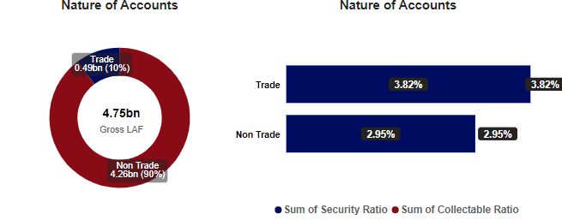
- Syndication
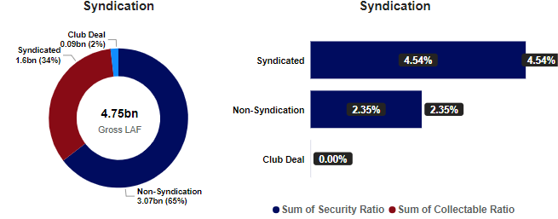
- Market type
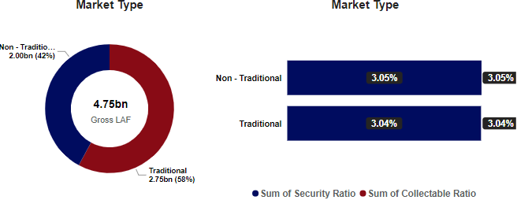
- Financing asset quality
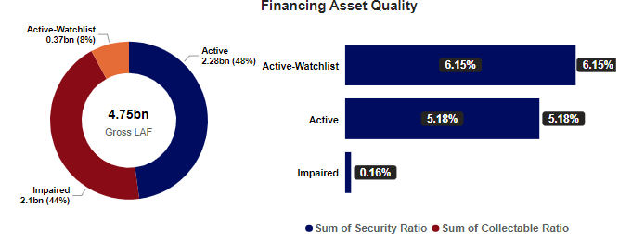
- Corporate Status
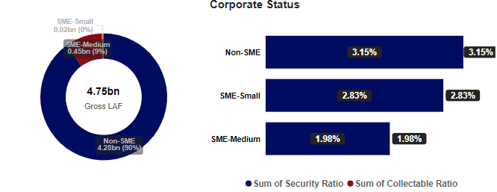
- Entity type
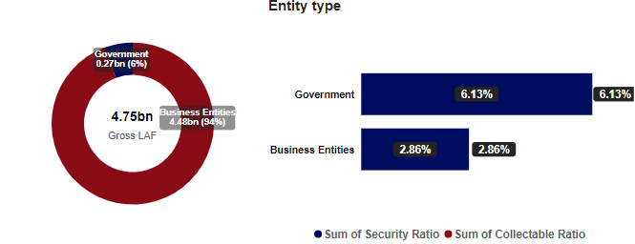
- Facility
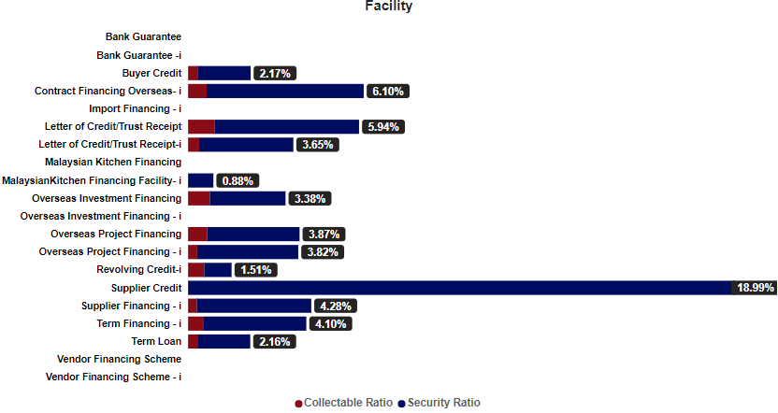
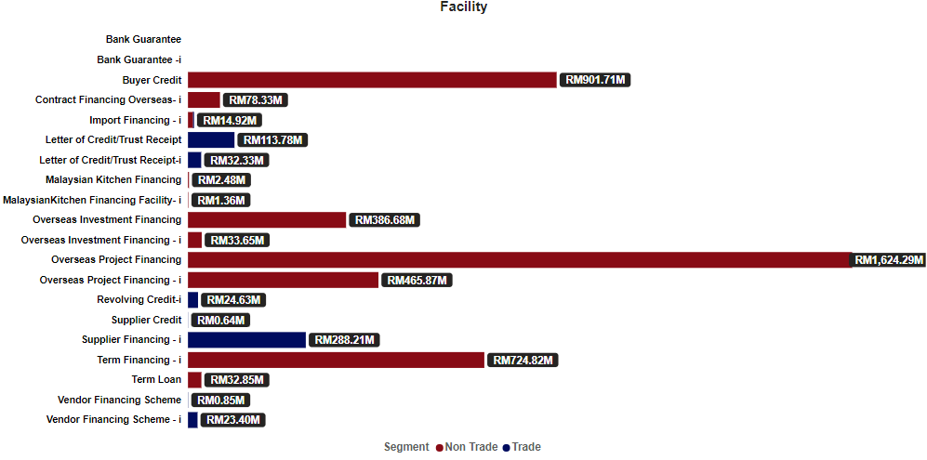

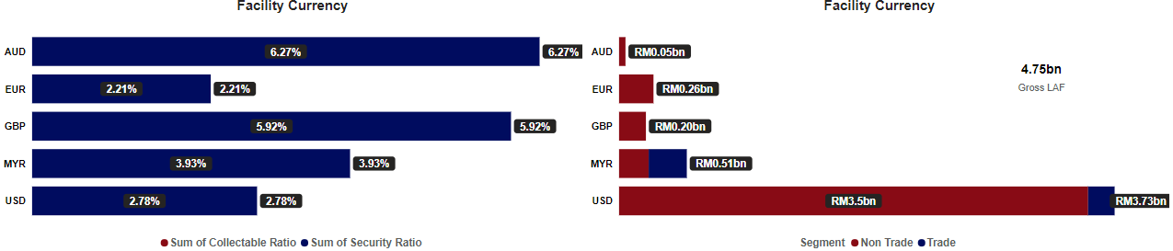
- Facility currency

- Country
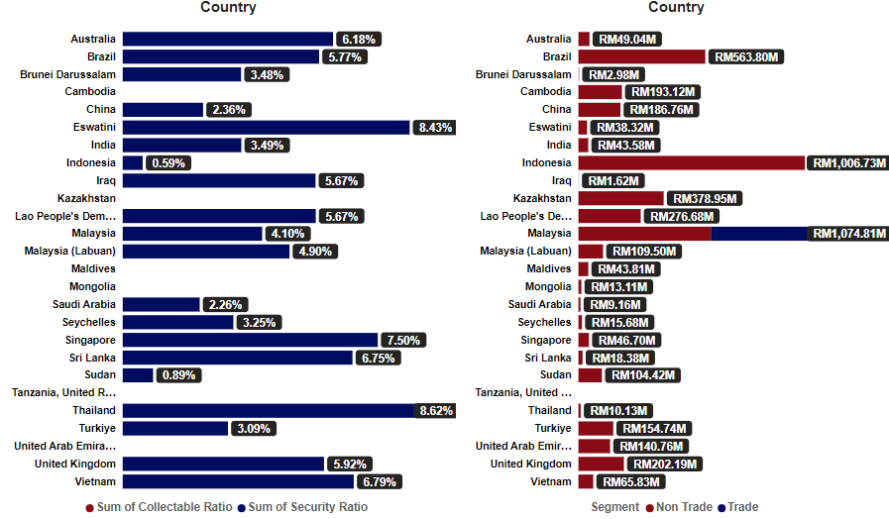
- BNM main sector
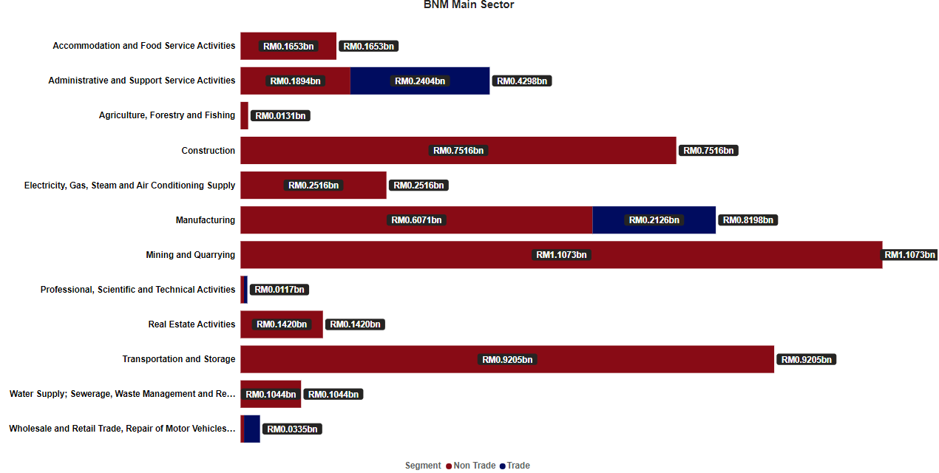
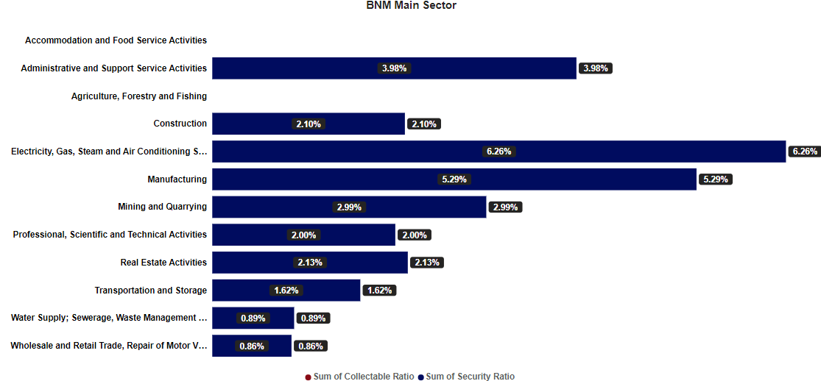
Figure 3.3

Security Criteria Prediction

- Trade secured profit score.

Trade financing has total of 24 branches/scenario, it predicted the capability of profit ranged from 0.023 bps to 0.420 bps security. Table below shows how are the most secured profit criteria:
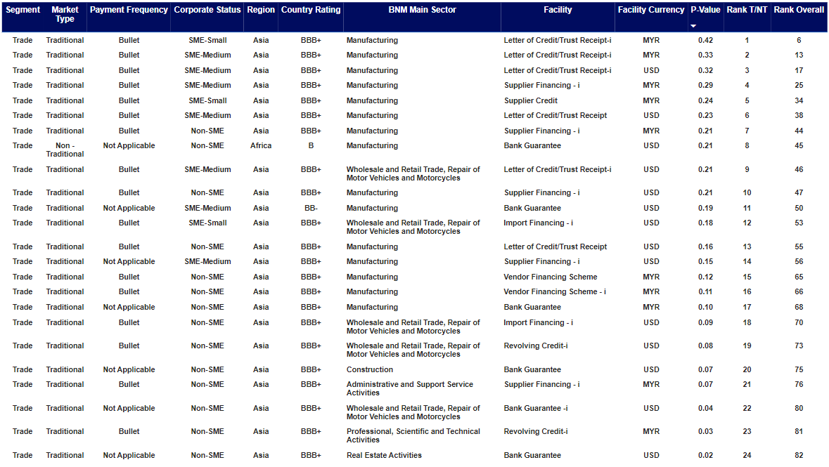
Table 3.0

- Non-Trade secured profit score.

Non-Trade financing has total of 59 branches/scenario, it predicted the capibility of profit ranged from 0.021 bps to 0.662 bps security. Table below shows top 25 of the secured profit criteria:
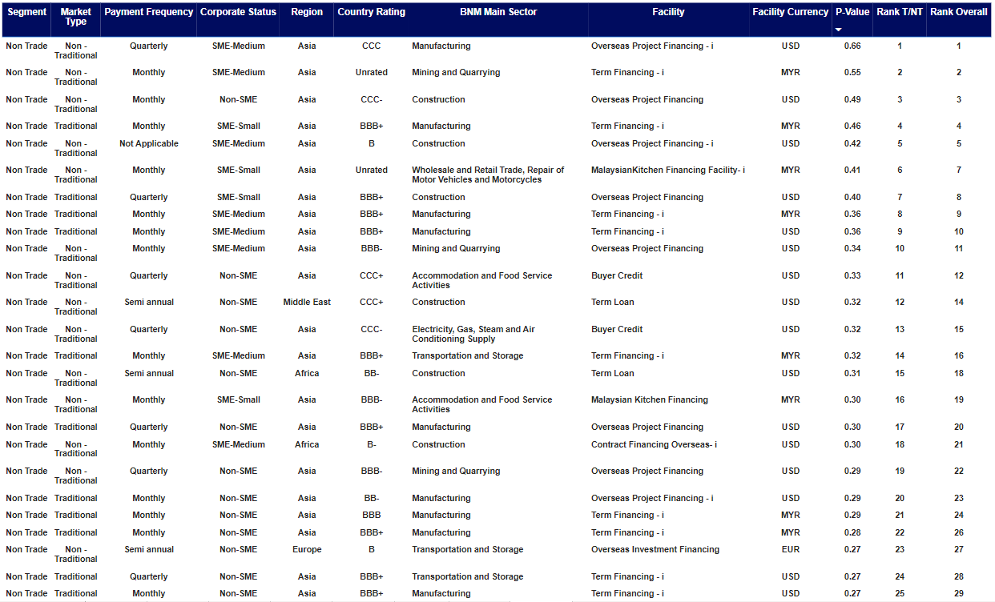
Table 3.1
- interpretation
From the graph/table resulted above, we could conclude the biggest loan does not indicate the safest or highest profit. Non-trade show highest ratio and the lowest ratio meaning though it can obtain most profit it also can end up with the least profit. Also, non-trade has more branches/scenario compared to trade indicates non-trade has higher risk and higher sensitivity for the profit and security to varies compared to trade.

Figure below shows sensitivity of 17 branches/scenario out of 24 branches link with the most profitable ratio:
Profit Security Score (Trade)
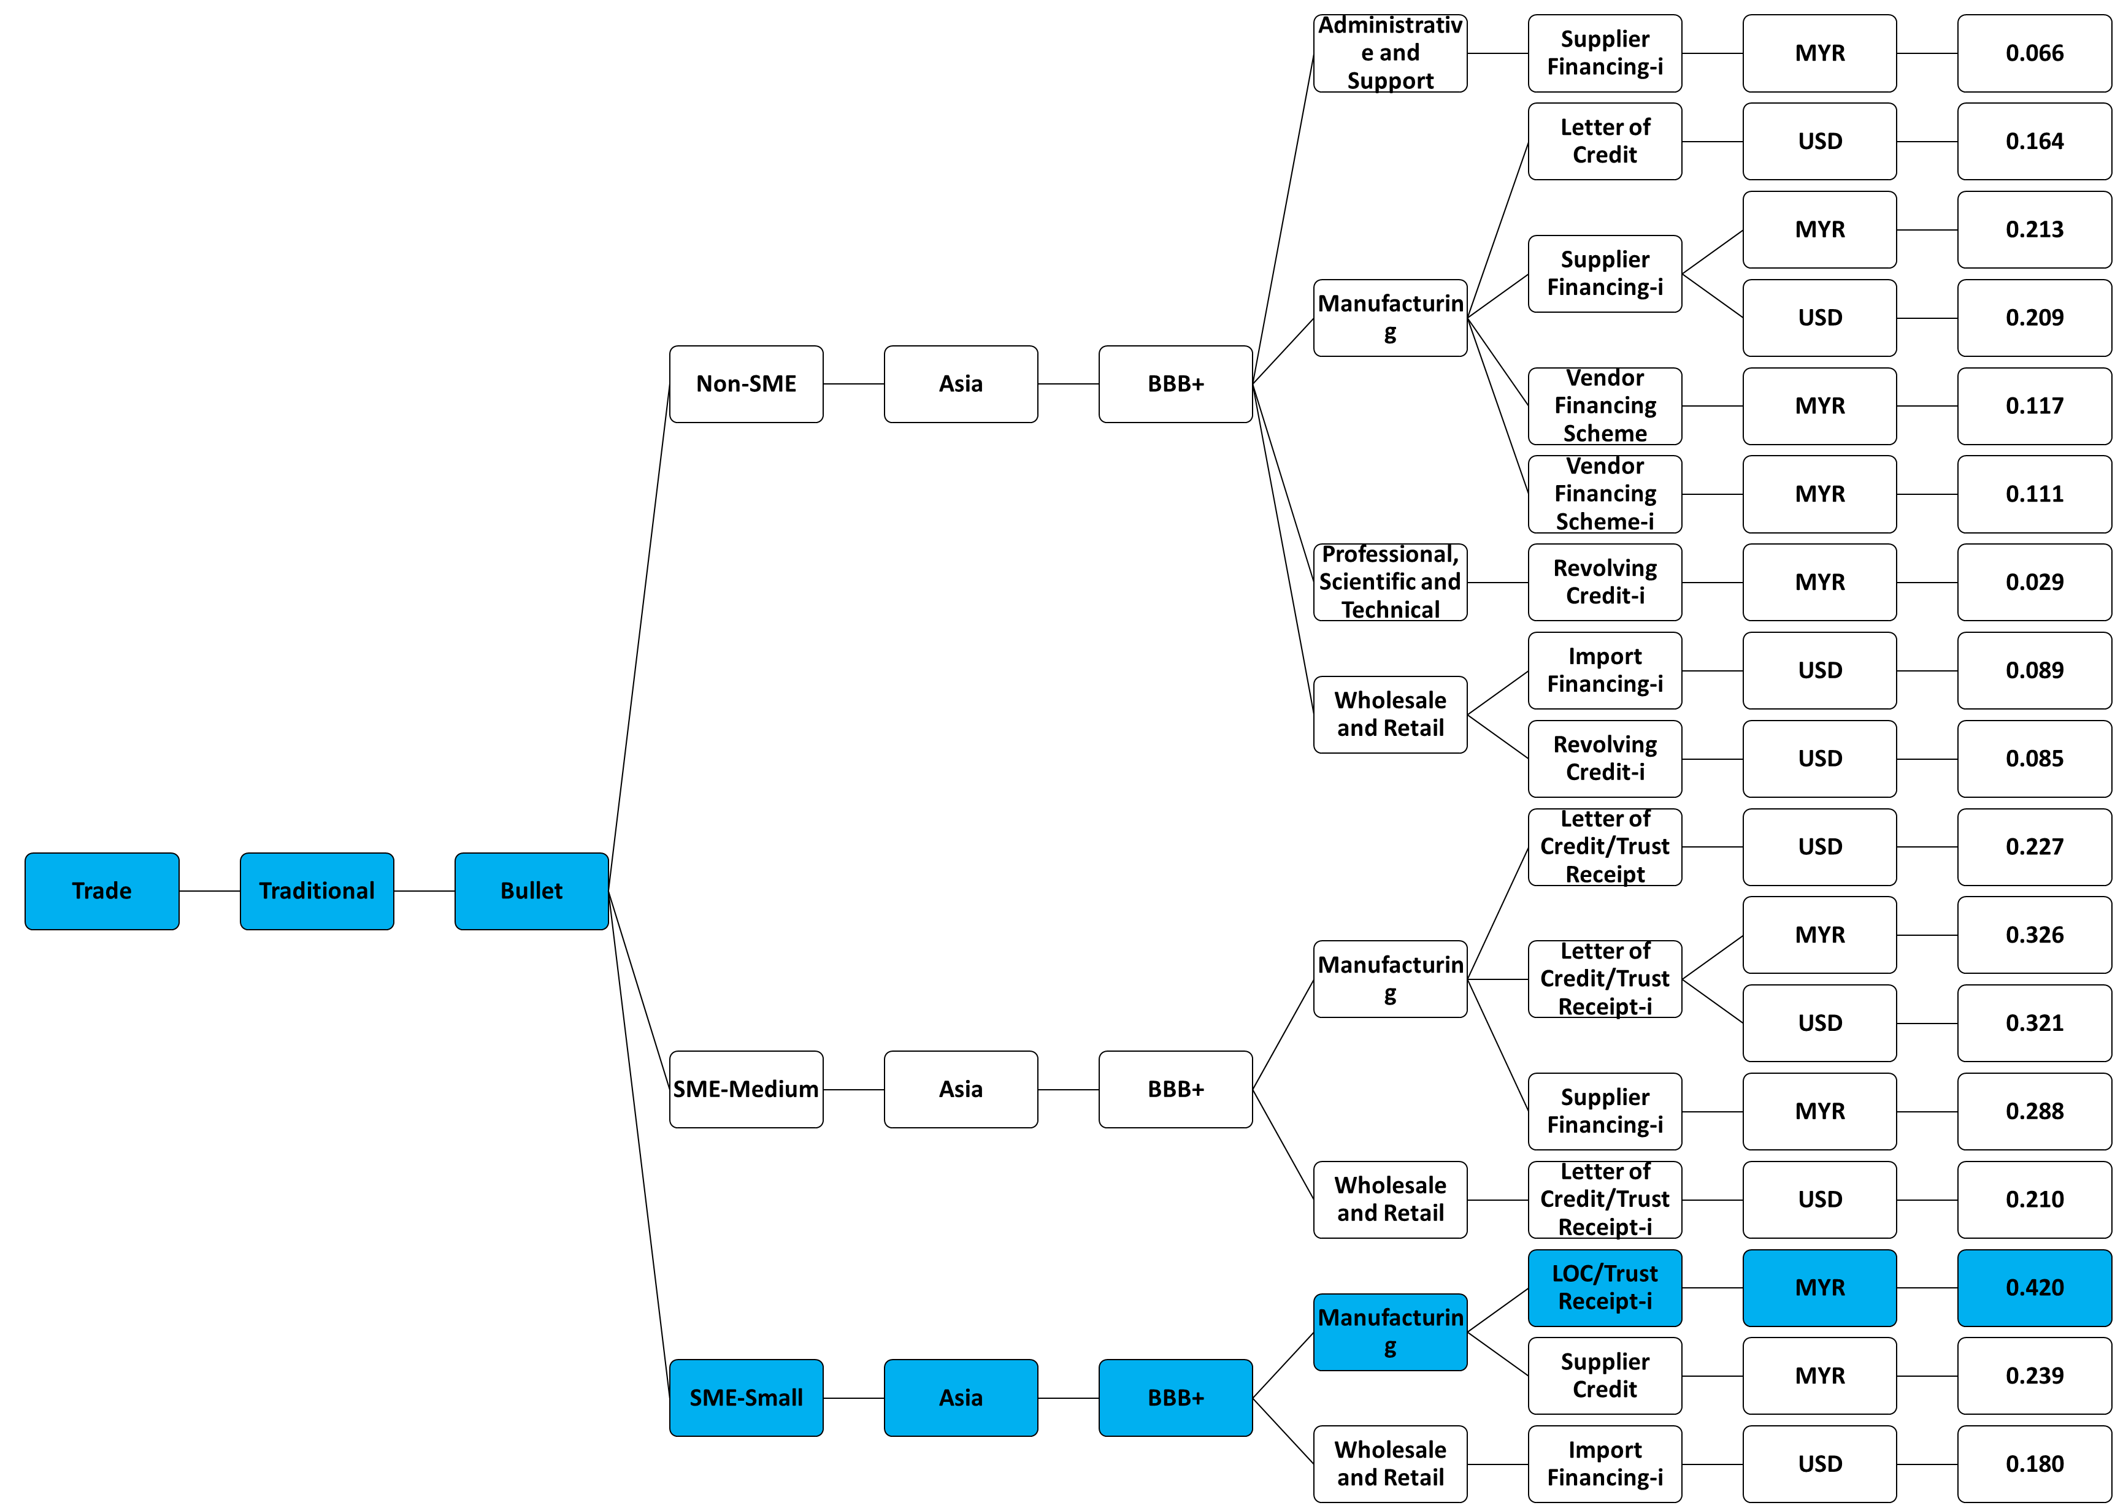
Figure below shows sensitivity of 7 branches/scenario out of 59 branches link with the most profitable ratio:
Profit Security Score (Non-Trade)
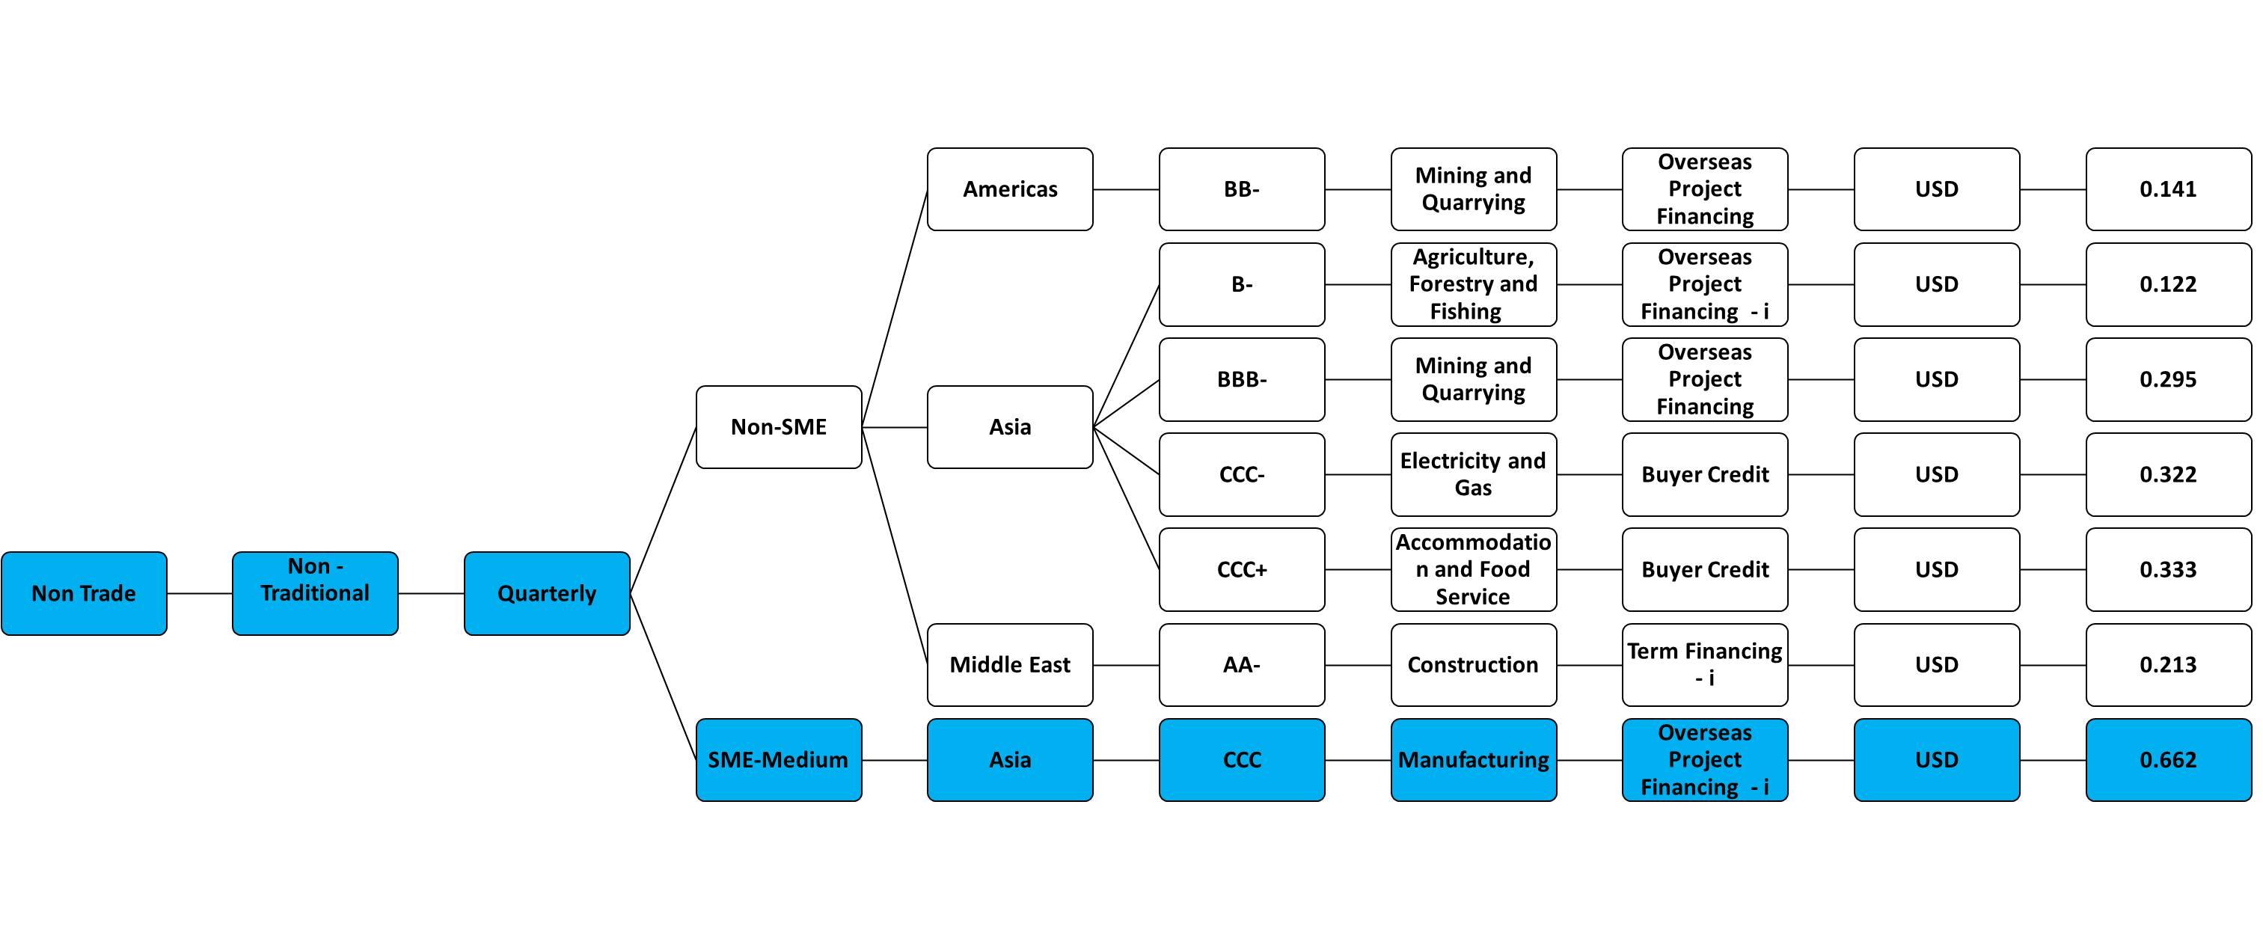

CUSTOMER-CENTRIC: HOLISTIC APPROACH

FINANCING ASSET QUALITY

EXECUTIVE SUMMARY

Overall Financing Asset

Even while the financing asset and cumulative profit payment is decreasing, the active customer appears to be doing better as of September 2023 compared to December 2020. Though it is looking good for the active customer, at the time being we should constantly be concerned because the impaired asset increases from 36.41% to 44.16% where ECL will also increase:

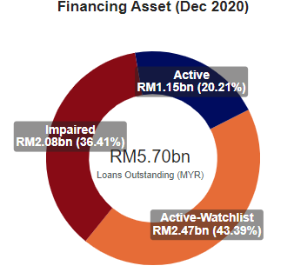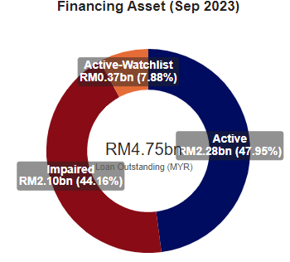
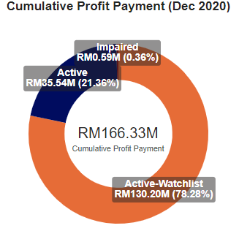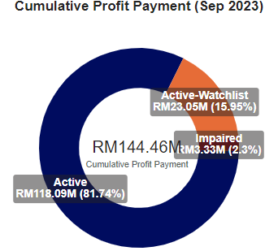
Figure 4.0
Since the decline of financing asset in the year 2020, it shows lesser watchlist customer means less ECL is allocated (1 year) which mean less cost. To decrease more cost, it advice to decrease the watchlist and impaired financing amount. Incontinuity, more cumulative profit can be generated because active customer makes more profit than watchlist and impaired customer:
There would be less cost and more quality profit for the bank when increase stage 1 (active) customer and decrease stage 2 (watchlist) and stage 3 (impaired) customer as per proven in the graph from December 2020 until September 2023 below:

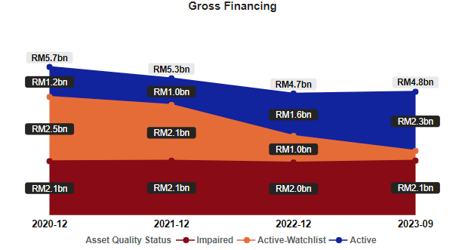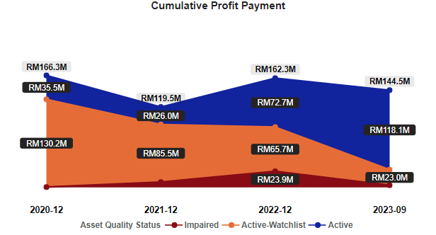
Figure 4.1
Figure below shows the number of impaired ratios as an overall, trade and non-trade also the number of impaired financings for trade and non-trade:
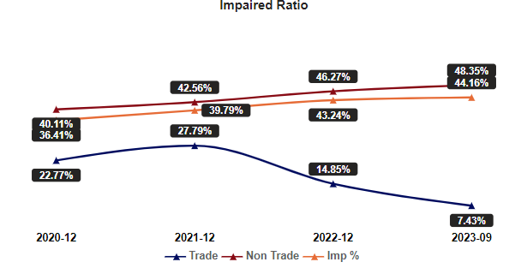
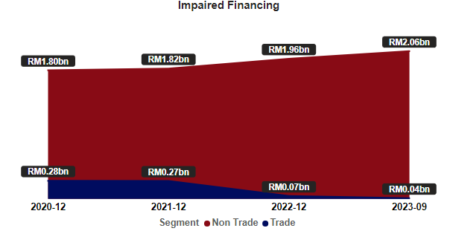
Figure 4.2
Overall impaired performance influenced by non-trade financing where the ratio shows the trade impaired ratio is decreasing from 22.77% to 7.43% while non-trade is increasing 40.11% to 48.35%. The total amount of impaired financing for non-trade increase from RM 1.80 billion to RM 2.06 billion while trade decrease from RM0.28 billion to RM 0.04 billion.

Impaired Ratio
Figure 4.3 below will display impaired ratio and gross financing from EXIM clients as of the most recent position by 5 different criteria. The most amounted financing asset does not directly indicate highest profit whereby the higher the profit ratio the more secure the profit. List of criteria as per below:
- Country
- Currency
- Facility
- BNM Main Sector
- Syndication
Impaired Ratio and Financing Asset:
- Country
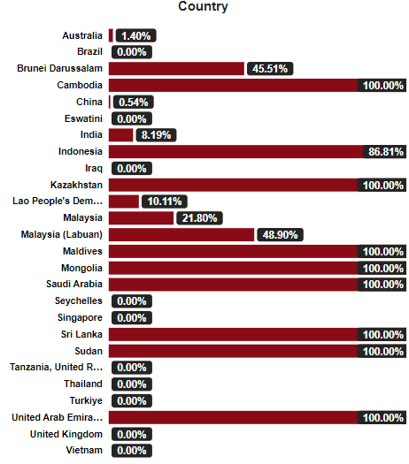

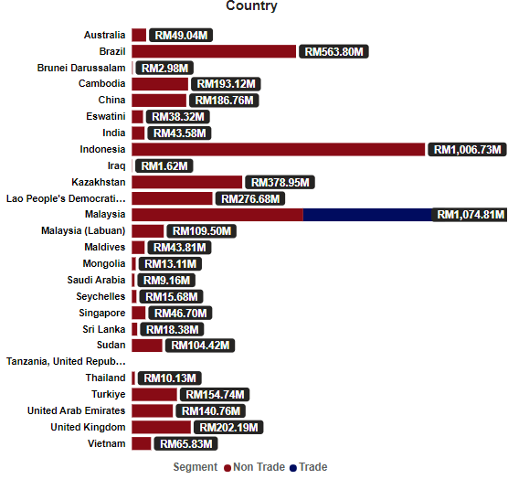
- Currency
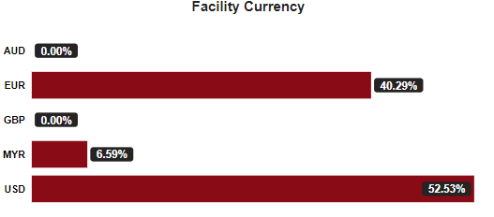

- Facility
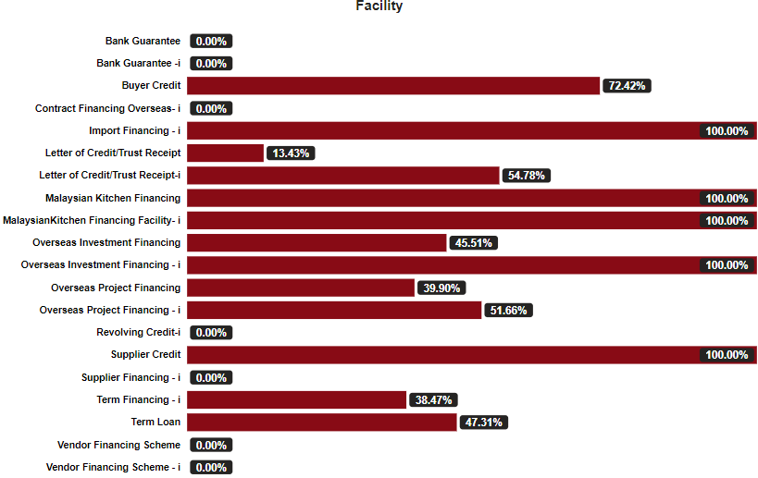

- BNM Main Sector
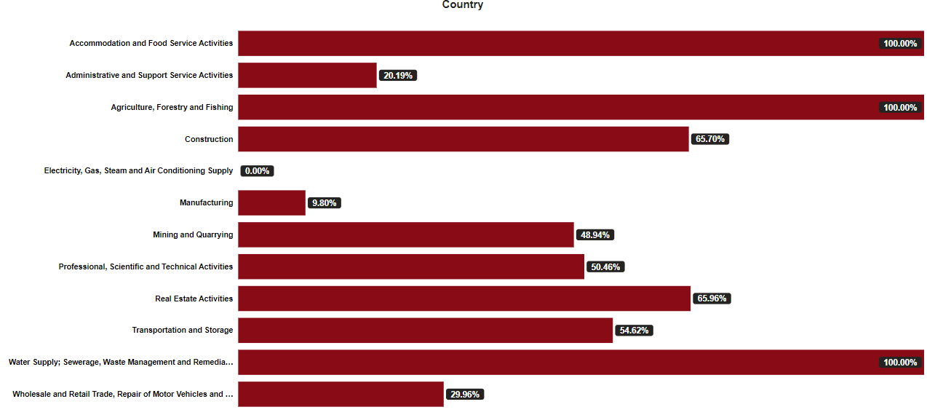

- Syndication
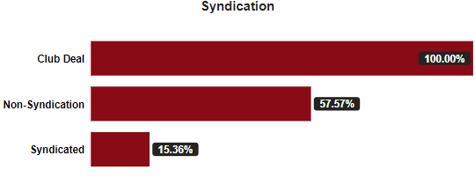
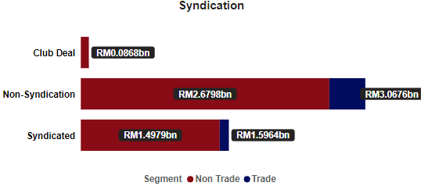
Figure 4.3
- interpretation
From the graph/table resulted above, we could conclude it proven the overall financing asset quality is improving influence by trade financing. The bigger the loan does not directly have the best quality of customer for example Indonesia number of financing asset but also has high impaired ratio. Also from the result, the most secure profit shows a positive correlation of good quality such as in country Thailand and Eswatini, even Sector in Electricity and Manufacturing activities.
Impaired Behaviour
Figure 4.4 below will display tenure to impaired ratio and number of months for certain criteria to turn impaired as of the most recent position by 5 different criteria. List of criteria as per below:
- Country
- Currency
- Facility
- BNM Main Sector
- Syndication
tenure to impaired ratio uses the average tenure and number of months for customer to turn impaired, a positive correlation will have a high positive ratio meaning higher the ratio less likely for a criterion to turn impaired, the 2nd graph will indicate how to turn impaired:
- Country
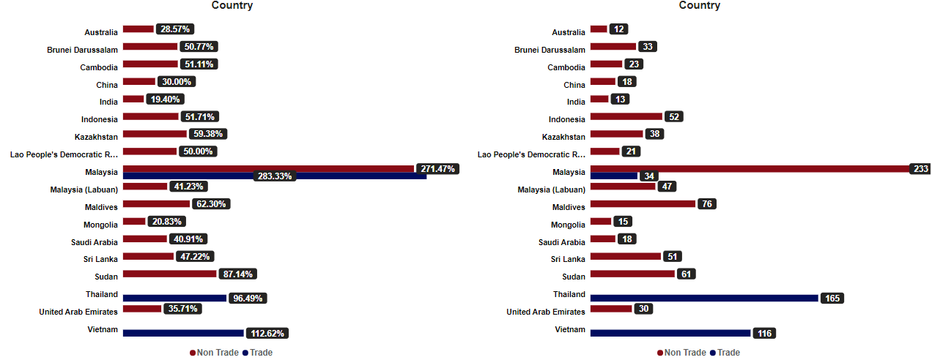
- Currency
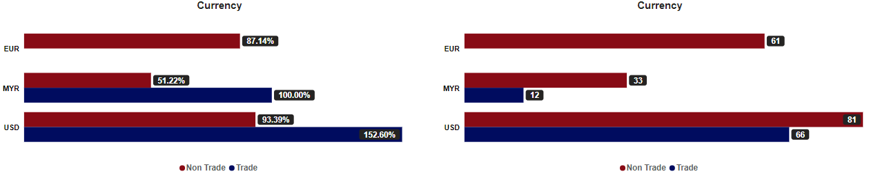
- Facility
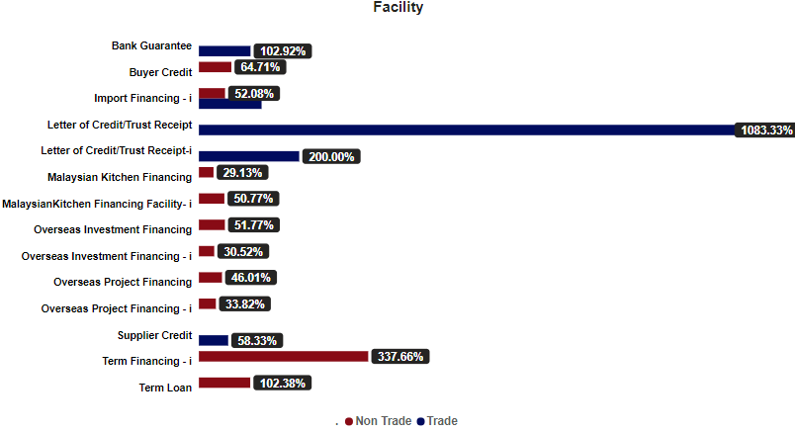

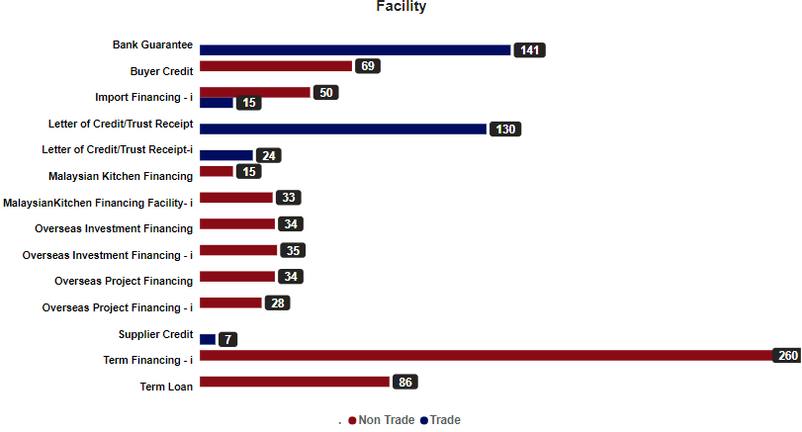
- BNM Main Sector
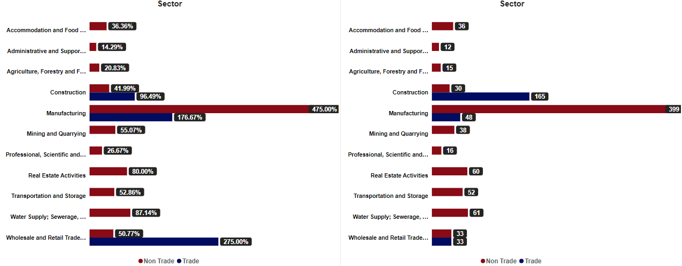
- Syndication
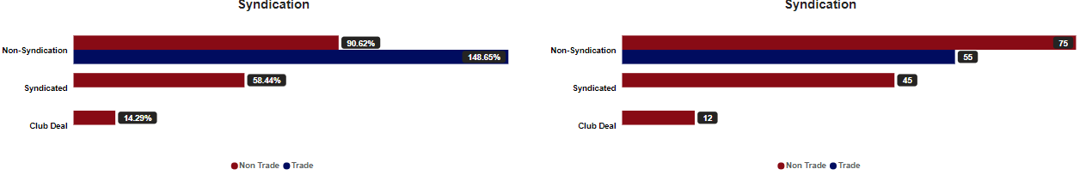
Figure 4.4
- interpretation
From the graph/table resulted above, most of non-trade criteria shows a possibility of how month most for a customer to turn impaired and trade has less likely to impaired. Example of Malaysia of trade and non-trade has the less most possibility to turn impaired while India and Mongolia have high chance of impaired by 13 months and 15 months respectively.

Accounts Migration

Table below shows number of accounts by asset quality segmentation throughout the year:

Financial Asset Quality | Dec 2020 | Dec 2021 | Dec 2022 | Sep 2023
All Accounts | 162 | 138 | 119 | 117
Active | 37 | 17 | 26 | 46
Watchlist | 55 | 49 | 31 | 19
Impaired | 70 | 72 | 62 | 52
Table 4.0

Table below shows that the number of accounts, gross financing asset & cumulative profit payment for movement of an accounts. Overall, new account increases slower than the churn accounts by migration segmentation:

Overall Account
Date | Dec 2020 | Dec 2021 | Dec 2022 | Sep 2023
Total | 162 Accounts | 138 Accounts | 119 Accounts | 117 Accounts
Account Movement | - | 24 Accounts | 19 Accounts | 2 Accounts
Gross Financing | RM5.70 billion | RM5.27 billion | RM4.68 billion | RM4.75 billion
C. Profit Payment | RM 0.17 billion | RM 0.12 billion | RM 0.16 billion | RM 0.14 billion
Maintain Accounts | - | 129 Accounts | 110 Accounts | 101 Accounts
Gross Financing | - | RM4.81 billion | RM4.32 billion | RM4.49 billion
C. Profit Payment | - | RM0.12 billion | RM0.15 billion | RM0.14 billion
New Accounts | - | 9 Accounts | 9 Accounts | 16 Accounts
Gross Financing | - | RM0.46 billion | RM0.37 billion | RM0.26 billion
C. Profit Payment | - | RM1.73 million | RM7.37 million | RM6.07 million
Churn Accounts | - | 33 Accounts | 28 Accounts | 18 Accounts
Gross Financing | - | RM0.437 billion | RM0.802 billion | RM0.249 billion
C. Profit Payment | - | RM13.89 million | RM15.79 million | RM13.47 million
Reason | - | 16 – Fully Settled  5 – Cancelled  5 – Conversion  4 – Expired  3 – Fully Write Off | 14 – Fully Settled  9 – Fully Write Off  5 – Cancelled | 8 – Fully Settled  8 – Fully Write-Off  1 – Cancelled  1 – Conversion
Cycle | - | 1 new account disburse for dismissed accounts after December 2021  (Yinson Boronia Production B.V, Non-Trade, Overseas Project Financing, Settled Malaysia, New to Brazil) | No new accounts disburse for dismissed accounts after December 2022 | -
Table 4.1

From the table below, the number of impaired accounts is decreasing, and new impaired account is also decreasing but most of the churn account in a concern when mostly the accounts in fully written off from EXIM book:

Impaired
Date | Dec 2020 | Dec 2021 | Dec 2022 | Sep 2023
Total | 70 Accounts | 72 Accounts | 62 Accounts | 52 Accounts
Account Movement | - | 2 Accounts | 10 Accounts | 10 Accounts
Gross Financing | RM2.08 billion | RM2.10 billion | RM2.02 billion | RM2.10 billion
C. Profit Payment | RM0.59 million | RM7.99 million | RM23.92 million | RM3.33 million
Maintain Accounts | - | 61 Accounts | 55 Accounts | 50 Accounts
Gross Financing | - | RM4.81 billion | RM1.79 billion | RM2.09 billion
C. Profit Payment | - | RM117.77 million | RM18.46 million | RM3.29 million
New Accounts | - | 11 Accounts | 7 Accounts | 2 Accounts
Gross Financing | - | RM0.46 billion | RM0.23 billion | RM0.006 billion
C. Profit Payment | - | RM1.73 million | RM5.47 million | RM0.04 million
Churn Accounts | - | 9 Accounts | 17 Accounts | 12 Accounts
Gross Financing | - | RM0.12 billion | RM0.37 billion | RM0.06 billion
C. Profit Payment | - | RM0.40 million | RM0.22 million | RM0.84 million
Reason | - | 3 – Fully Write-Off  3 – Fully Settled  3 – Conversion | 9 – Fully Write-Off  6 – Fully Settled  2 – Watchlist | 8 – Fully Write-Off  3 – Watchlist  1 – Cancelled
Table 4.2

Cycle Diagram
Most of EXIM Bank customer is good churn when fully settled, so even the bad churn such as fully write-off is from impaired customer. Below shows the cycle diagrams for EXIM Bank customer:

Dec 2021 – 0.46 billion
Dec 2022 – 0.37 billion
Sep 2023 – 0.36 billion
New Accounts
Dec 2021 - Yinson Boronia B.V
Fully Settled
Fully Write Off
Cancelled
Conversion
Expired

Diagram 4.0

Customer Churn Prediction
The prediction uses logistic regression model, one of supervised machine learning algorithm that is used to predict the probability of an outcome. The model can indicate whether an active (46 Accounts) will turn to watchlist (19 Accounts) and then whether it will turn impaired (52 Accounts) or not by setting up the correct parameter to predict those accounts. Listed parameter as per below:
- Trade/Non-Trade Segmentation
- Traditional/Non-Traditional Trade Market
- Customer Payment Frequency
- Customer Corporate Status
- Country Region
- S&P/Moodys Country Rating
- Customer Main Sector
- Customer Facility
- Facility Currency
Matrix table:
Active  to Watchlist | Suc-Obs | Fail_Obs |  |  | Watchlist to Impaired | Suc-Obs | Fail_Obs
Suc-Pred | 11 | 5 |  |  | Suc-Pred | 50 | 7
Fail-Pred | 8 | 41 |  |  | Fail-Pred | 2 | 12
80.00% | 57.89% | 89.13% |  |  | 87.32% | 96.15% | 63.16%

Table 4.3

First matrix table: it predicted 8 (RM118 million gross financing) watchlist accounts will turn active by accuracy of 57.89% and 5 (RM 168 million gross financing) active accounts will turn watchlist by 89.13%. The model shows accuracy of 80.00%.
Second matrix table: it predicted 2 (RM 104 million gross financing) impaired accounts will turn watchlist by accuracy of 96.15% and 7 (RM 330 million gross financing) watchlist accounts will turn impaired by 63.16%. The model shows accuracy of 87.32%
Below shows the potential listing table based on the model:
- Listing of possible active accounts to turn watchlist:
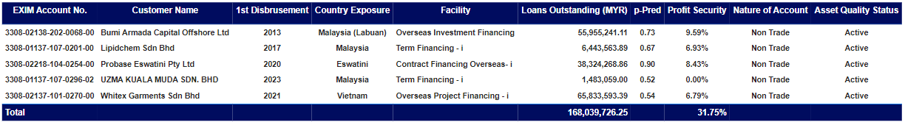

- Listing of possible watchlist accounts to turn active:
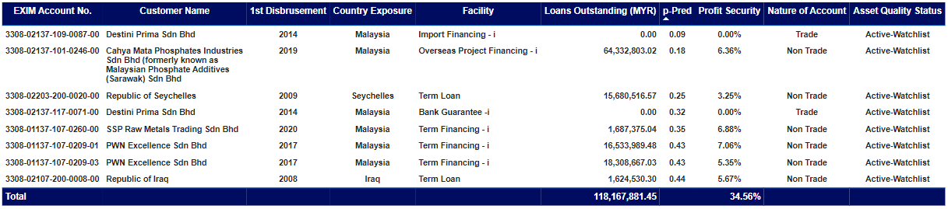

- Listing of possible watchlist accounts to turn impaired:
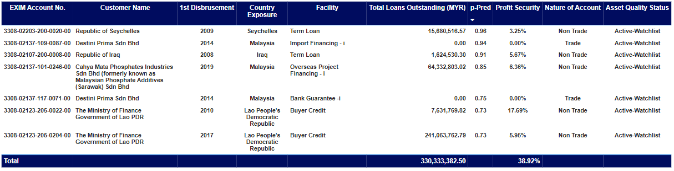

- Listing of possible impaired accounts to turn watchlist:

The Receiver Operating Characteristic (ROC) curves illustrates the diagnostic ability to determine for an account to churn or vice versa. Under the ROC curves the overall account performance based on the 9 parameters listed above, if the probability of impairment for an account is above 0.5 in figure below, we consider for the account as churn while below 0.5 says otherwise.
ROC Curve:
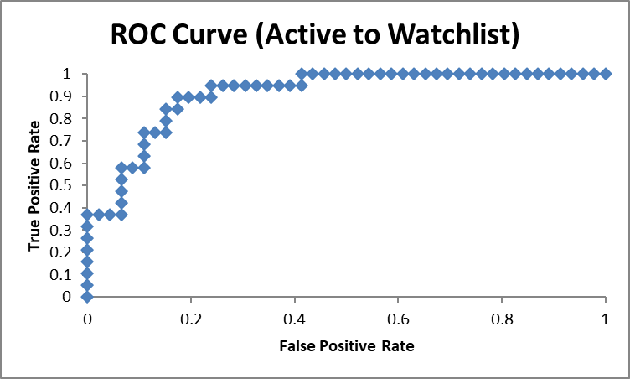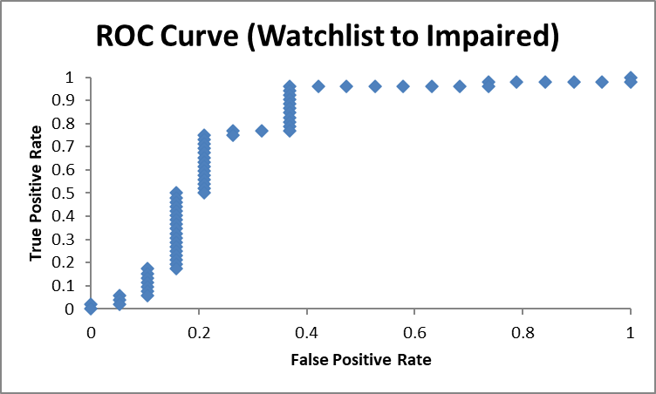
Figure 4.5

- Trade Quality Risk Score (Active - Watchlist)

Trade has total of 17 branches/scenario, it is sorted from the most safest score to the worst quality score for a customer. Value ranged from 0.019 bps to 0.604 bps. Table below shows the active quality criteria:

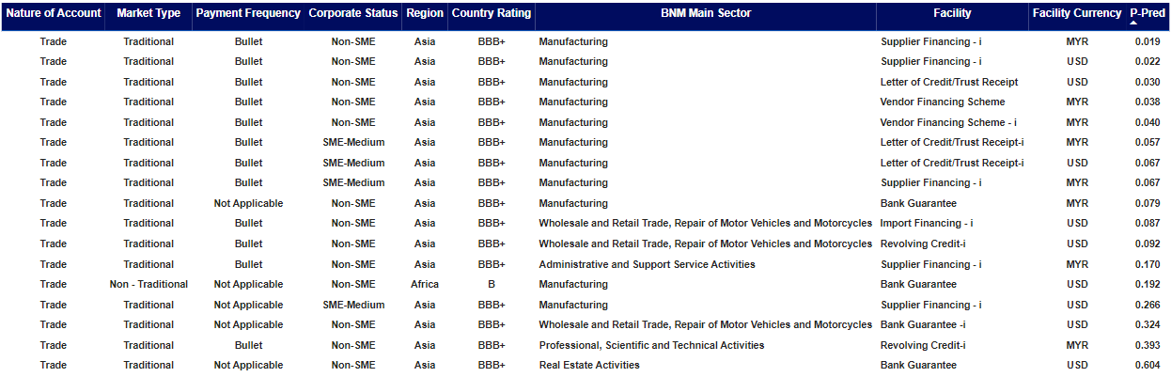 Table 4.3

- Non-Trade Quality Risk Score (Active - Watchlist)

Non-trade has total of 26 branches/scenario, it is sorted from the most safest to the worst quality for a customer. Value ranged from 0.007 bps to 0.984 bps. Table below shows the active quality criteria:

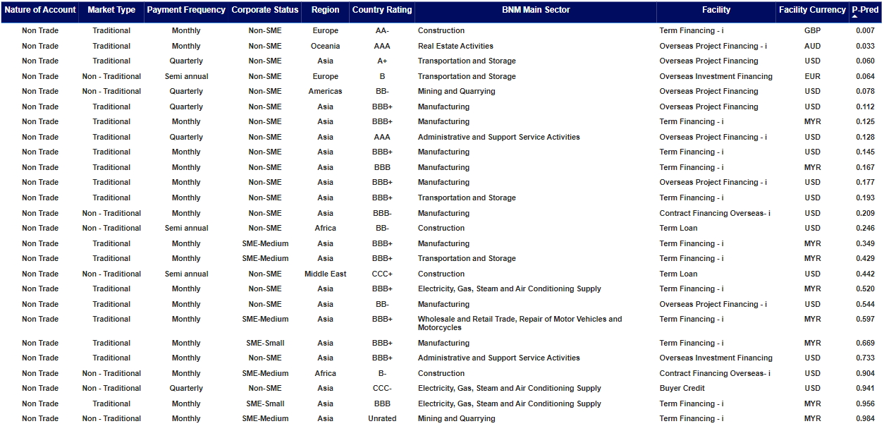
Table 4.4

- Trade Quality Risk Score (Watchlist - Impaired)

Trade has total of 11 branches/scenario, it is sorted by the worst score of quality customer ranged from 0.375 bps to 0.945 bps. Table below shows the impaired quality criteria:

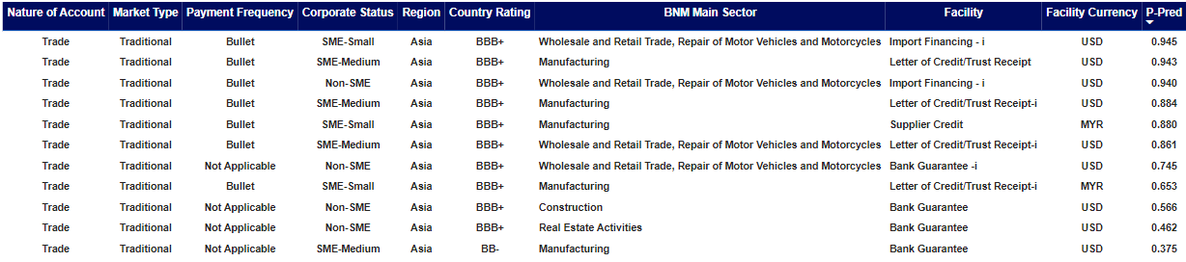
Table 4.5

- Non-Trade Quality Risk Score (Watchlist - Impaired)

Non-trade has total of 43 branches/scenario, it is sorted by the worst score of quality customer ranged from 0.109 bps to 0.967 bps. Table below shows the impaired quality criteria:

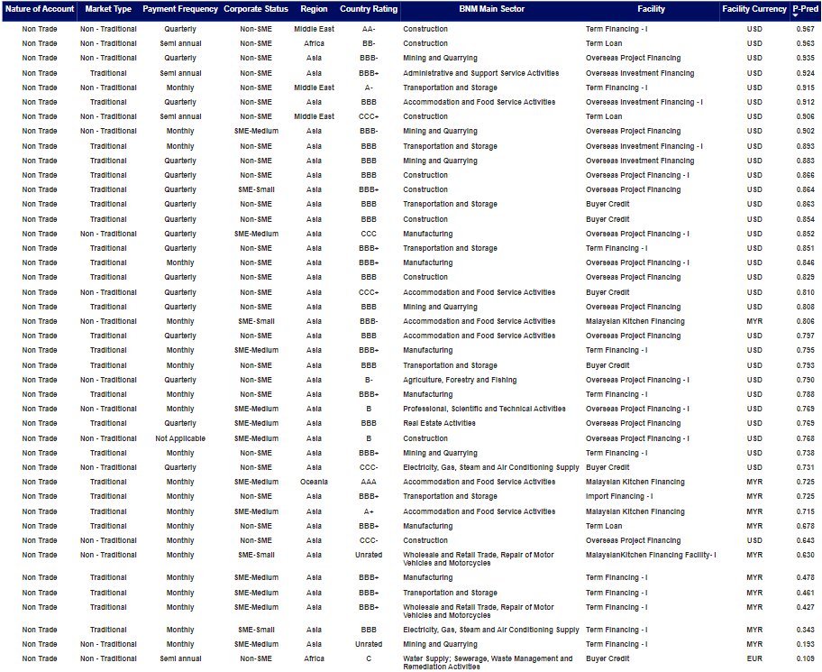
Table 4.6

Figures below shows sensitivity of 10 branches/scenario out of 17 branches link with the safest score for trade to remain active/stage 1:
Active Criteria Score (Trade)

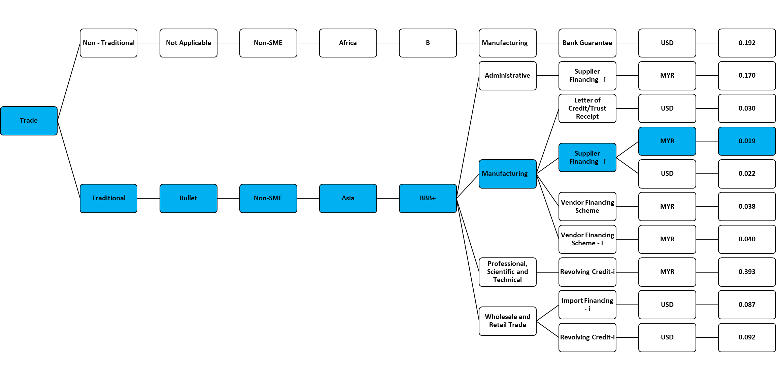Figure 5.0
Figures below shows sensitivity of 10 branches/scenario out of 26 branches link with the safest score for non-trade to remain active/stage 1:
Active Criteria Score (Non-Trade)

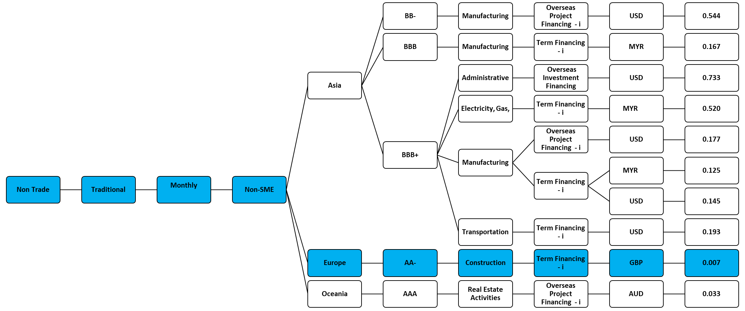
Figure 5.1
Figures below shows sensitivity of 11 branches/scenario out of 11 branches link with the most concern score for trade to become impaired/stage 3:
Impaired Criteria Score (Trade)

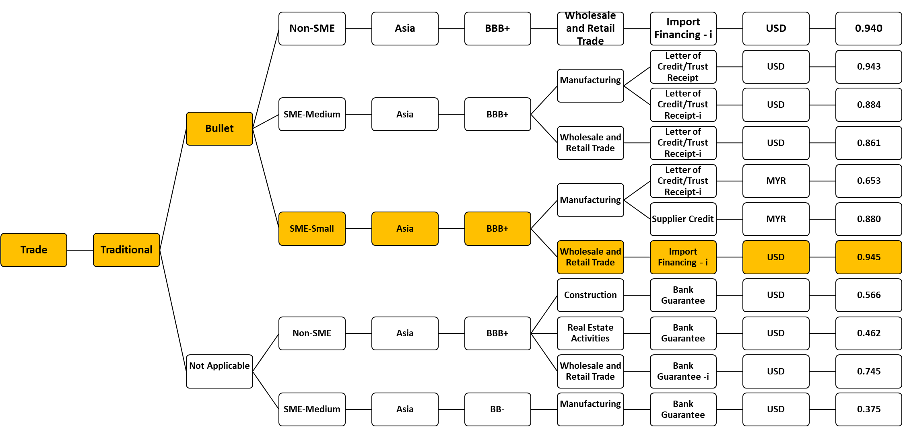
Figure 5.2
Figures below shows sensitivity of 7 branches/scenario out of 59 branches link with the most concern score for trade to become impaired/stage 3:
Impaired Criteria Score (Non-Trade)

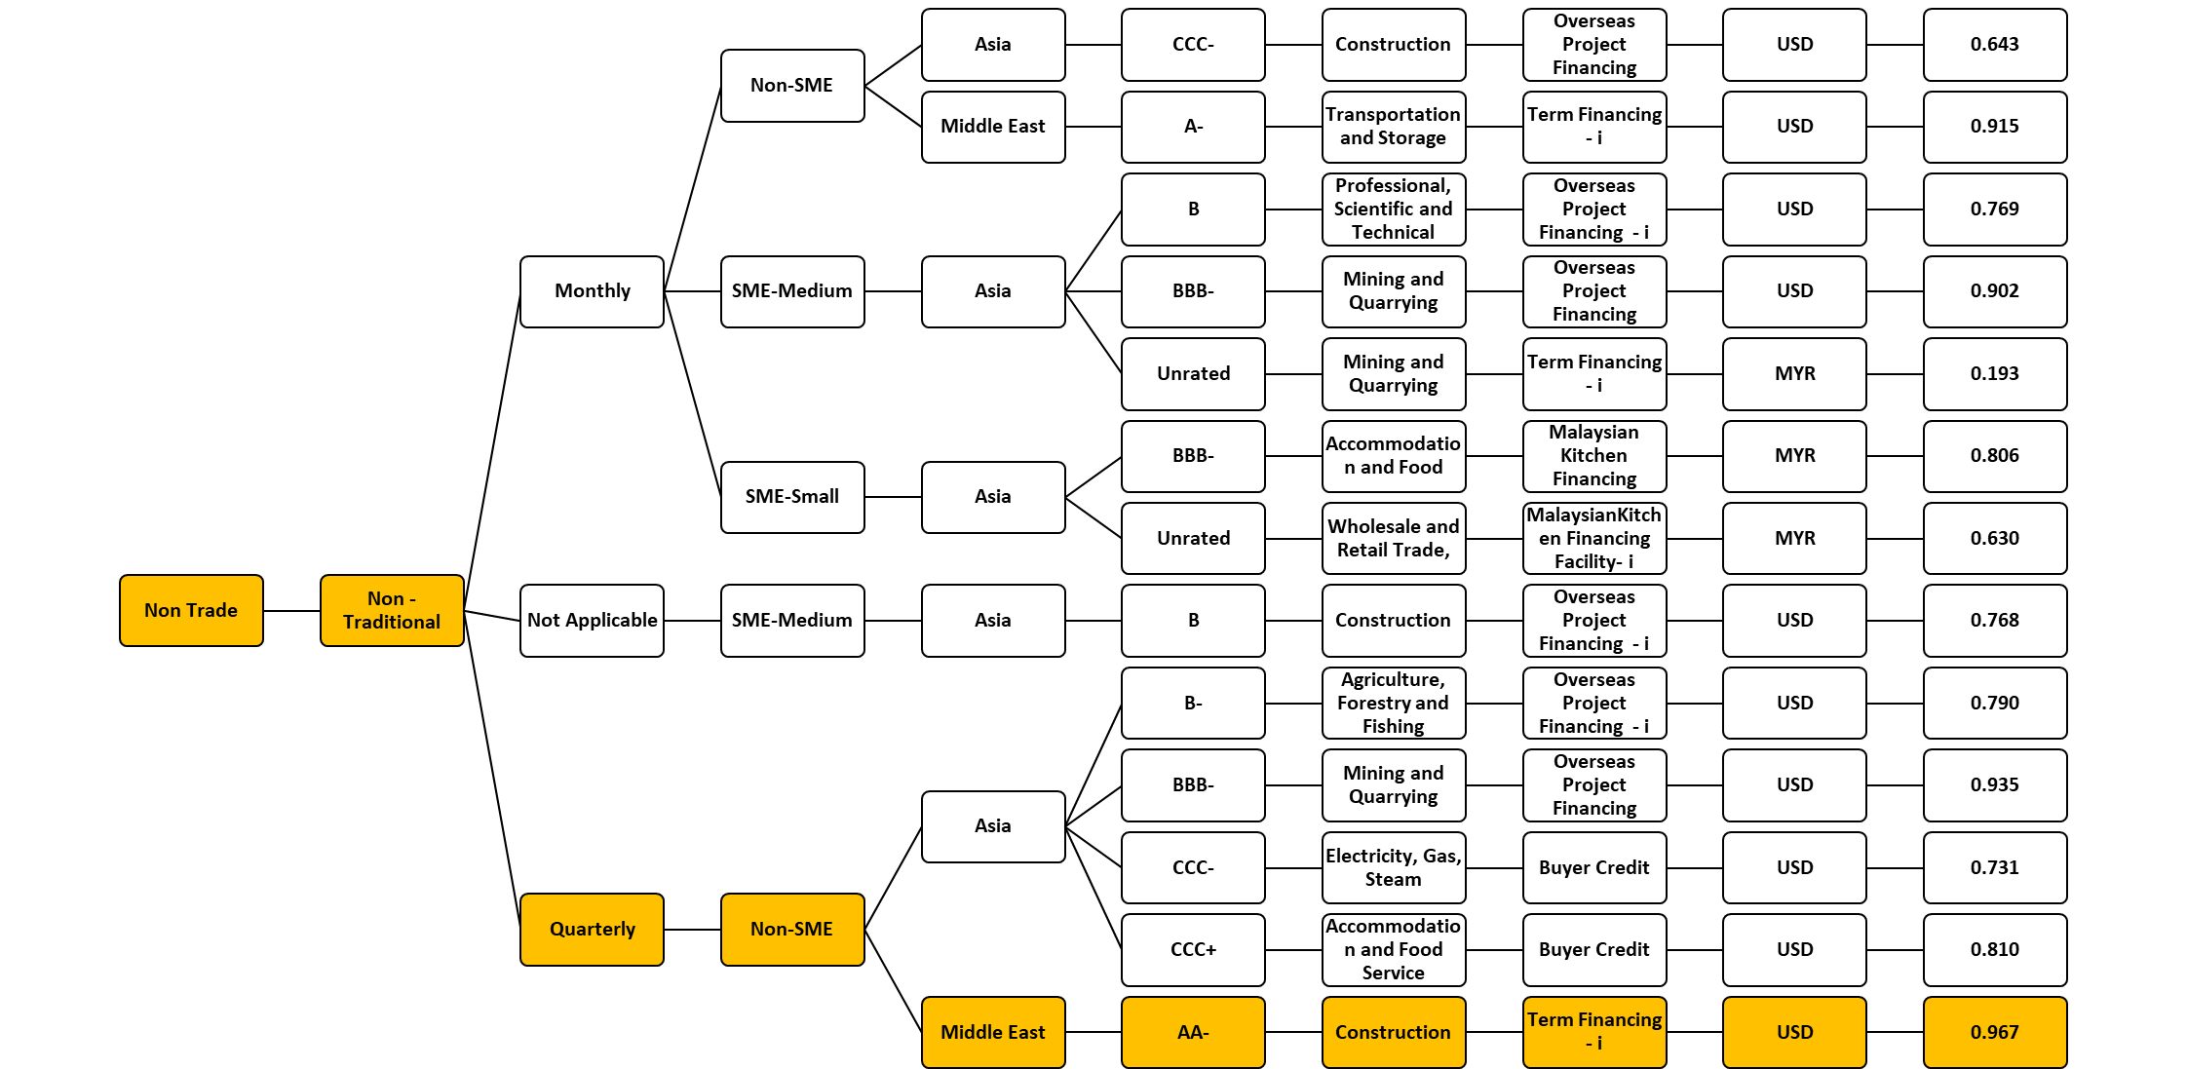
Figure 5.3

Research Question:
“Which of Trade and Non-Trade is more quality in term of profit and financing asset? Which is risker to do business and where could EXIM Bank focus to expand for more profit? How does EXIM Bank perform complying the mandated role?”

Key Takeaway:
“EXIM Bank of Malaysia has fulfilled its mandate by providing credit facilities to finance and support exports and imports of goods, services, and overseas projects to 26 different countries with 20 different facility and 5 different currencies across different sectors and entities. With non-trade being 90% of its financing asset, trade is more secure whereby 10% of trade is making 3.82% of profit compared to non-trade only at 2.95%. As well as the countries EXIM Bank has ventured into, the underserved countries such as Thailand and Eswatini are more secure compared to UAE, Saudi and many more. The research also found sector in Electricity, Gas, Steam and Air Conditioning Services has more secure profit by 6.29% compared to the highest amounted loan, Mining and Quarrying by 2.99%. These high secure profits not only show good performance in getting profit but rather in term of the customer quality as well, it shows good indicator in payment/repayment for trade customer, customer expose in Thailand and Eswatini, and even customer venture into Electricity, Gas, Steam and Air Conditioning Services. Therefore, believing that our focus in profit security will pay off, a better profit security for the bank to generate profit will gives confident for the bank to recognise its long-term growth strategy.”

Appendix
The following figure lists the top 15 customers in terms of largest loan:
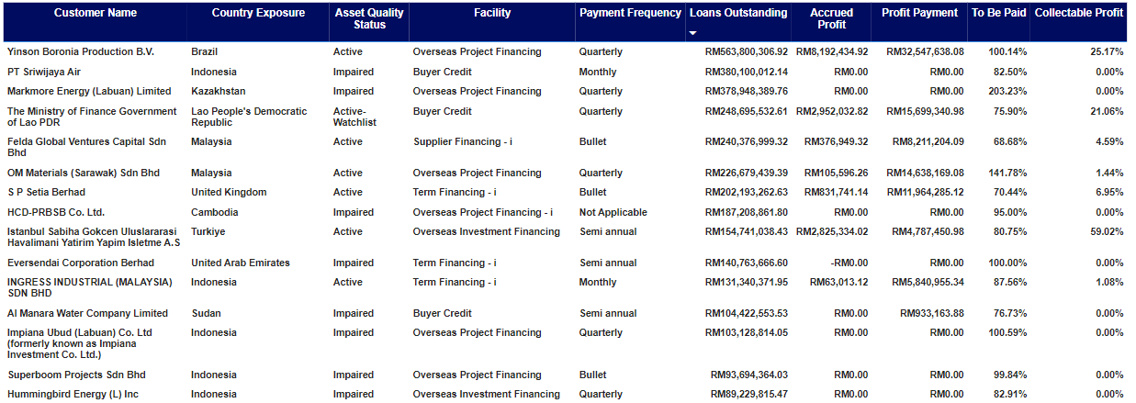
Table 5.0

The following figure lists the top 15 impaired customers in terms of largest loan:
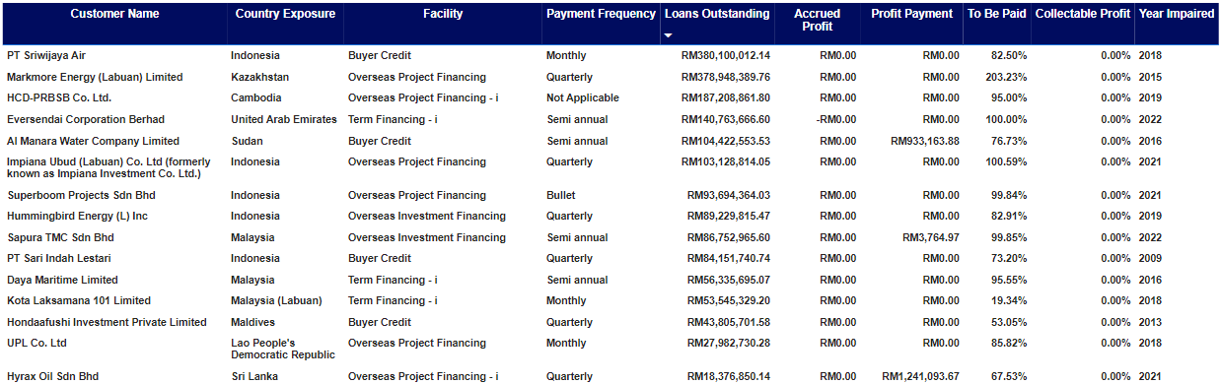
Figure 5.1
The following figure lists the top 15 impaired customers in terms of longest impaired:
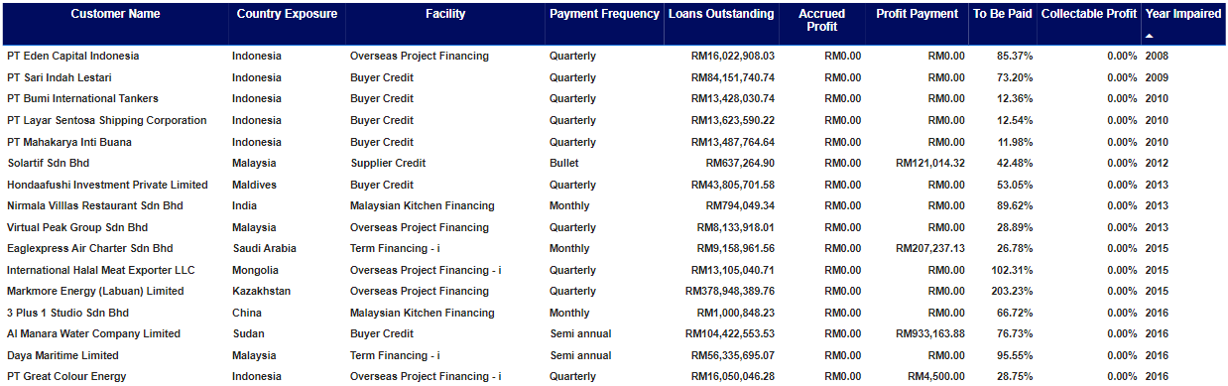
Figure 5.2
The following table Shows the country fitch rating by its region and country exposure:
Country Rating | Region | Country Exposure
AAA | Asia | Singapore
AAA | Europe | Germany
AAA | Oceania | Australia
AA+ | Americas | Canada
AA+ | Americas | United States
AA+ | Oceania | New Zealand
AA- | Asia | Chinese Taipei / Taiwan
AA- | Asia | Korea, Republic of (South)
AA- | Europe | United Kingdom
AA- | Middle East | United Arab Emirates
A+ | Asia | China
A | Asia | Japan
A- | Middle East | Saudi Arabia
BBB+ | Asia | Malaysia
BBB+ | Asia | Malaysia (Labuan)
BBB+ | Asia | Thailand
BBB+ | Europe | Spain
BBB | Asia | Indonesia
BBB- | Asia | India
BBB- | Asia | Kazakhstan
BB- | Africa | Seychelles
BB- | Americas | Brazil
BB- | Asia | Bangladesh
BB- | Asia | Vietnam
B | Africa | Tanzania, United Republic of
B | Asia | Cambodia
B | Europe | Türkiye
B- | Africa | Eswatini
B- | Africa | Ghana
B- | Asia | Mongolia
B- | Europe | Bosnia and Herzegovina
CCC+ | Asia | Maldives
CCC+ | Middle East | Iraq
CCC | Asia | Sri Lanka
CCC- | Asia | Lao People's Democratic Republic
C | Africa | Sudan
Unrated | Asia | Brunei Darussalam
Table 2.0

